Biochemical Oxygen Demand

29-Oct-24

Name: Faizan

Registration # FA21-BSE-011

# Dataset Assigned

BOD (Biochemical Oxygen Demand).

# Minkowski Distance

Minkowski distance is the generalization of Euclidean distance. Euclidean Distance Length of the line segment between two points in a Euclidean space is known as the Euclidean Distance [1].

## RStudio implementation

### Loading the dataset to memory:

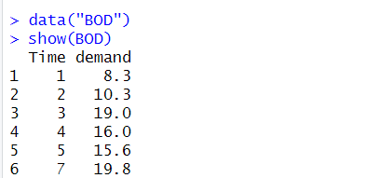

### Exporting the dataset to a CSV file and importing it

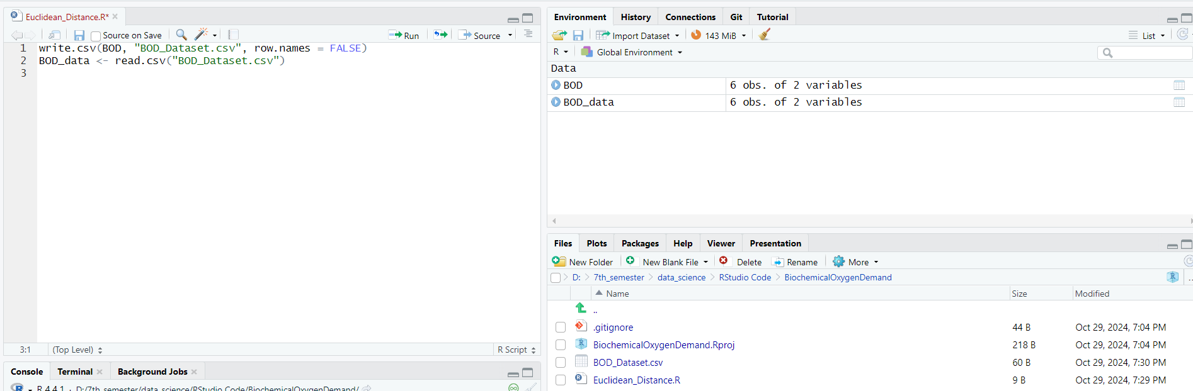

### Calculating the Euclidean, city block and supremum distance by putting r= 1, 2, and ∞ on the imported dataset

# Load the BOD dataset and save it to a CSV

write.csv(BOD, "BOD_Dataset.csv", row.names = FALSE)

# Read the dataset back into R

BOD_data <- read.csv("BOD_Dataset.csv")

# Define a generalized Minkowski distance function

minkowski_dist <- function(x, y, r) {

if (r == Inf) {

return(max(abs(x - y))) # L∞ norm (Supremum distance)

} else {

return((sum(abs(x - y)^r))^(1/r)) # Lr norm (Minkowski distance)

}

}

# Get the number of demands

n <- length(BOD_data$demand)

# Initialize matrices to hold the distances

manhattan_distances <- matrix(NA, n, n)

euclidean_distances <- matrix(NA, n, n)

supremum_distances <- matrix(NA, n, n)

# Set values for r

r_values <- c(1, 2, Inf) # 1 = Manhattan, 2 = Euclidean, Inf = Supremum

# Calculate the distances for each pair

for (i in 1:n) {

for (j in 1:n) {

manhattan_distances[i, j] <- minkowski_dist(BOD_data$demand[i], BOD_data$demand[j], r_values[1])

euclidean_distances[i, j] <- minkowski_dist(BOD_data$demand[i], BOD_data$demand[j], r_values[2])

supremum_distances[i, j] <- minkowski_dist(BOD_data$demand[i], BOD_data$demand[j], r_values[3])

}

}

# Print the distance matrices

cat("Manhattan Distance Matrix (r=1):\n")

print(manhattan_distances)

cat("\nEuclidean Distance Matrix (r=2):\n")

print(euclidean_distances)

cat("\nSupremum Distance Matrix (r=∞):\n")

print(supremum_distances)

print(distances)

#### Output

# SMC (Simple Matching Coefficient)

Also known as the statistic used for comparing the similarities between sample sets [2].

## Implementation

1. We initialize a threshold to convert the data into binary

threshold <- mean(BOD_data$demand)

#Converting the data to binary

binary_demand <- ifelse(BOD_data$demand > threshold, 1, 0)

1. Treating both 1s and 0s

n <- length(binary_demand)

P_11 <- sum(binary_demand %*% t(binary_demand)) # Both 1s

P_00 <- sum((1 - binary_demand) %*% t(1 - binary_demand)) #Both 0s

1. Calculating the total number of similarities and SMC

#Total number of comparisons

N <- n * n

#Calculating Simple Matching Coefficients

SMC <- (P_11 + P_00) / N

print(SMC)

### Output

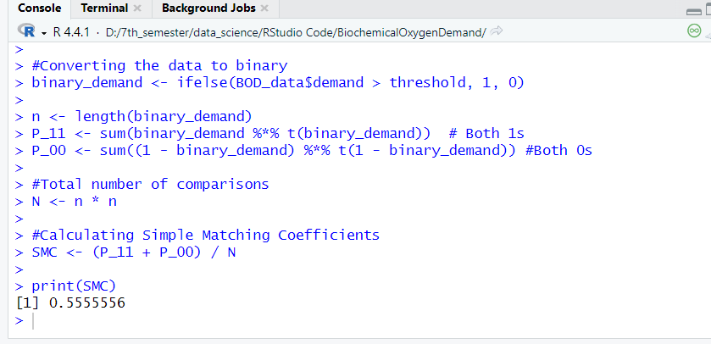

# Jaccard Coefficient

Also known as Jaccard index, is a statistic used to find out the similarity and diversity of sample sets [3].

## Implementation

threshold <- 15 # Example threshold

binary_demand <- ifelse(BOD$demand > threshold, 1, 0)

n <- length(binary_demand)

# Initialize counts for M11, M01, and M10

M_11 <- 0

M_01 <- 0

M_10 <- 0

# Loop through each pair to count M11, M01, and M10

for (i in 1:n) {

for (j in 1:n) {

if (i != j) {

if (binary_demand[i] == 1 && binary_demand[j] == 1) {

M_11 <- M_11 + 1

} else if (binary_demand[i] == 0 && binary_demand[j] == 1) {

M_01 <- M_01 + 1

} else if (binary_demand[i] == 1 && binary_demand[j] == 0) {

M_10 <- M_10 + 1

}

}

}

}

# Calculate Jaccard Coefficient

jaccard_coefficient <- M_11 / (M_11 + M_01 + M_10)

print(jaccard_coefficient)

### Output

# Cosine Similarity

The cosine measure computes the *angle* between the two documents, which is **insensitive** to the absolute length of the document

## Implementation

# Load the BOD dataset and save it to a CSV

write.csv(BOD, "BOD_Dataset.csv", row.names = FALSE)

#or load it instead

#load("BOD")

# Read the dataset back into R

BOD_data <- read.csv("BOD_Dataset.csv")

# Define a function to calculate cosine similarity

cosine_similarity <- function(x, y) {

dot_product <- sum(x * y)

magnitude_x <- sqrt(sum(x^2))

magnitude_y <- sqrt(sum(y^2))

# Calculate cosine similarity

if (magnitude_x == 0 || magnitude_y == 0) {

return(NA) # Avoid division by zero

} else {

return(dot_product / (magnitude_x * magnitude_y))

}

}

# Get the number of demands

n <- length(BOD_data$demand)

# Initialize a matrix to hold the cosine similarities

cosine_similarities <- matrix(NA, n, n)

# Calculate the cosine similarity for each pair

for (i in 1:n) {

for (j in 1:n) {

cosine_similarities[i, j] <- cosine_similarity(BOD_data$demand[i], BOD_data$demand[j])

}

}

# Print the cosine similarity matrix

cat("Cosine Similarity Matrix:\n")

print(cosine_similarities)

### Output

# Correlation

* Correlation measures the **linear relationship** between the attributes of the objects yk=axk+b for binary or continuous variable
* Measure of linear dependency b/w two variables x and y

## Implementation

# Load the BOD dataset

BOD_data <- read.csv("BOD_Dataset.csv")

# Extract the Time and Demand columns

time <- BOD_data$Time

demand <- BOD_data$demand

# Calculate means

mean_time <- mean(time)

mean_demand <- mean(demand)

# Calculate covariance

covariance <- sum((time - mean_time) * (demand - mean_demand)) / length(time)

# Calculate standard deviations

std_dev_time <- sqrt(sum((time - mean_time)^2) / length(time))

std_dev_demand <- sqrt(sum((demand - mean_demand)^2) / length(demand))

# Calculate Pearson correlation coefficient

correlation_coefficient <- covariance / (std_dev_time * std_dev_demand)

# Print results

cat("Mean Time:", mean_time, "\n")

cat("Mean Demand:", mean_demand, "\n")

cat("Covariance:", covariance, "\n")

cat("Standard Deviation of Time:", std_dev_time, "\n")

cat("Standard Deviation of Demand:", std_dev_demand, "\n")

cat("Pearson Correlation Coefficient:", correlation_coefficient, "\n")

### Output

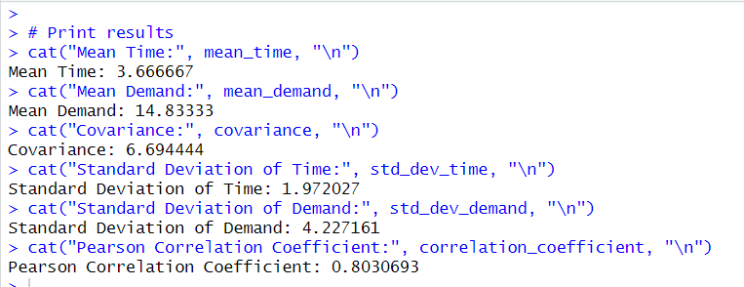

# Clustering using the distance matrix

# Load the BOD dataset and save it to a CSV

write.csv(BOD, "BOD_Dataset.csv", row.names = FALSE)

# Read the dataset back into R

BOD_data <- read.csv("BOD_Dataset.csv")

# Binarize the demand data based on a threshold

threshold <- 15

BOD_data$binarized_demand <- ifelse(BOD_data$demand > threshold, 1, 0)

# Define the distance functions

euclidean_dist <- function(x, y) {

sqrt(sum((x - y) ^ 2))

}

minkowski_dist <- function(x, y, r) {

sum(abs(x - y) ^ r)^(1/r)

}

cosine_similarity <- function(x, y) {

dot_product <- sum(x * y)

magnitude_x <- sqrt(sum(x^2))

magnitude_y <- sqrt(sum(y^2))

if (magnitude_x == 0 || magnitude_y == 0) {

return(NA) # Avoid division by zero

} else {

return(dot_product / (magnitude_x * magnitude_y))

}

}

# Get the number of demands

n <- nrow(BOD_data)

demand_matrix <- as.matrix(BOD_data$demand)

# Calculate distance matrices

euclidean_matrix <- matrix(NA, n, n)

minkowski_matrix <- matrix(NA, n, n)

cosine_matrix <- matrix(NA, n, n)

# Calculate the distance matrices

for (i in 1:n) {

for (j in 1:n) {

# Using demand values for distance measures

euclidean_matrix[i, j] <- euclidean_dist(demand_matrix[i, , drop = FALSE], demand_matrix[j, , drop = FALSE])

minkowski_matrix[i, j] <- minkowski_dist(demand_matrix[i, , drop = FALSE], demand_matrix[j, , drop = FALSE], r = 3) # r can be 1, 2, or 3

cosine_matrix[i, j] <- cosine_similarity(demand_matrix[i, , drop = FALSE], demand_matrix[j, , drop = FALSE])

}

}

# Print the distance matrices

cat("Euclidean Distance Matrix:\n")

print(euclidean_matrix)

cat("\nMinkowski Distance Matrix:\n")

print(minkowski_matrix)

cat("\nCosine Similarity Matrix:\n")

print(cosine_matrix)

# Clustering using K-means based on Euclidean distance

set.seed(123) # For reproducibility

k <- 2 # Number of clusters

# Since K-means uses Euclidean distance, we will use the original demand matrix

kmeans_result <- kmeans(demand_matrix, centers = k)

# Add cluster assignment to the original dataset

BOD_data$cluster <- kmeans_result$cluster

# Print the clustering result

cat("\nK-means Clustering Results:\n")

print(BOD_data)

## Output

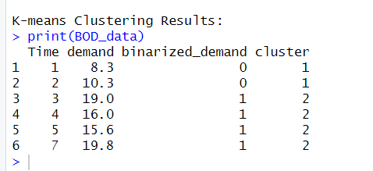

# References

1. <https://en.wikipedia.org/wiki/Euclidean_distance>
2. <https://en.wikipedia.org/wiki/Simple_matching_coefficient#:~:text=The%20simple%20matching%20coefficient%20(SMC,and%20diversity%20of%20sample%20sets.&text=value%201%2C%20and-,is%20the%20total%20number%20of%20attributes%20where%20A%20has,and%20B%20has%20value%200>.
3. https://en.wikipedia.org/wiki/Jaccard_index